Lyrical Genius Test Docs

Sign Up Testing

Test Case

* Try to fill in and submit an invalid form
* Complete a valid form submit
* Check database

Invalid Form

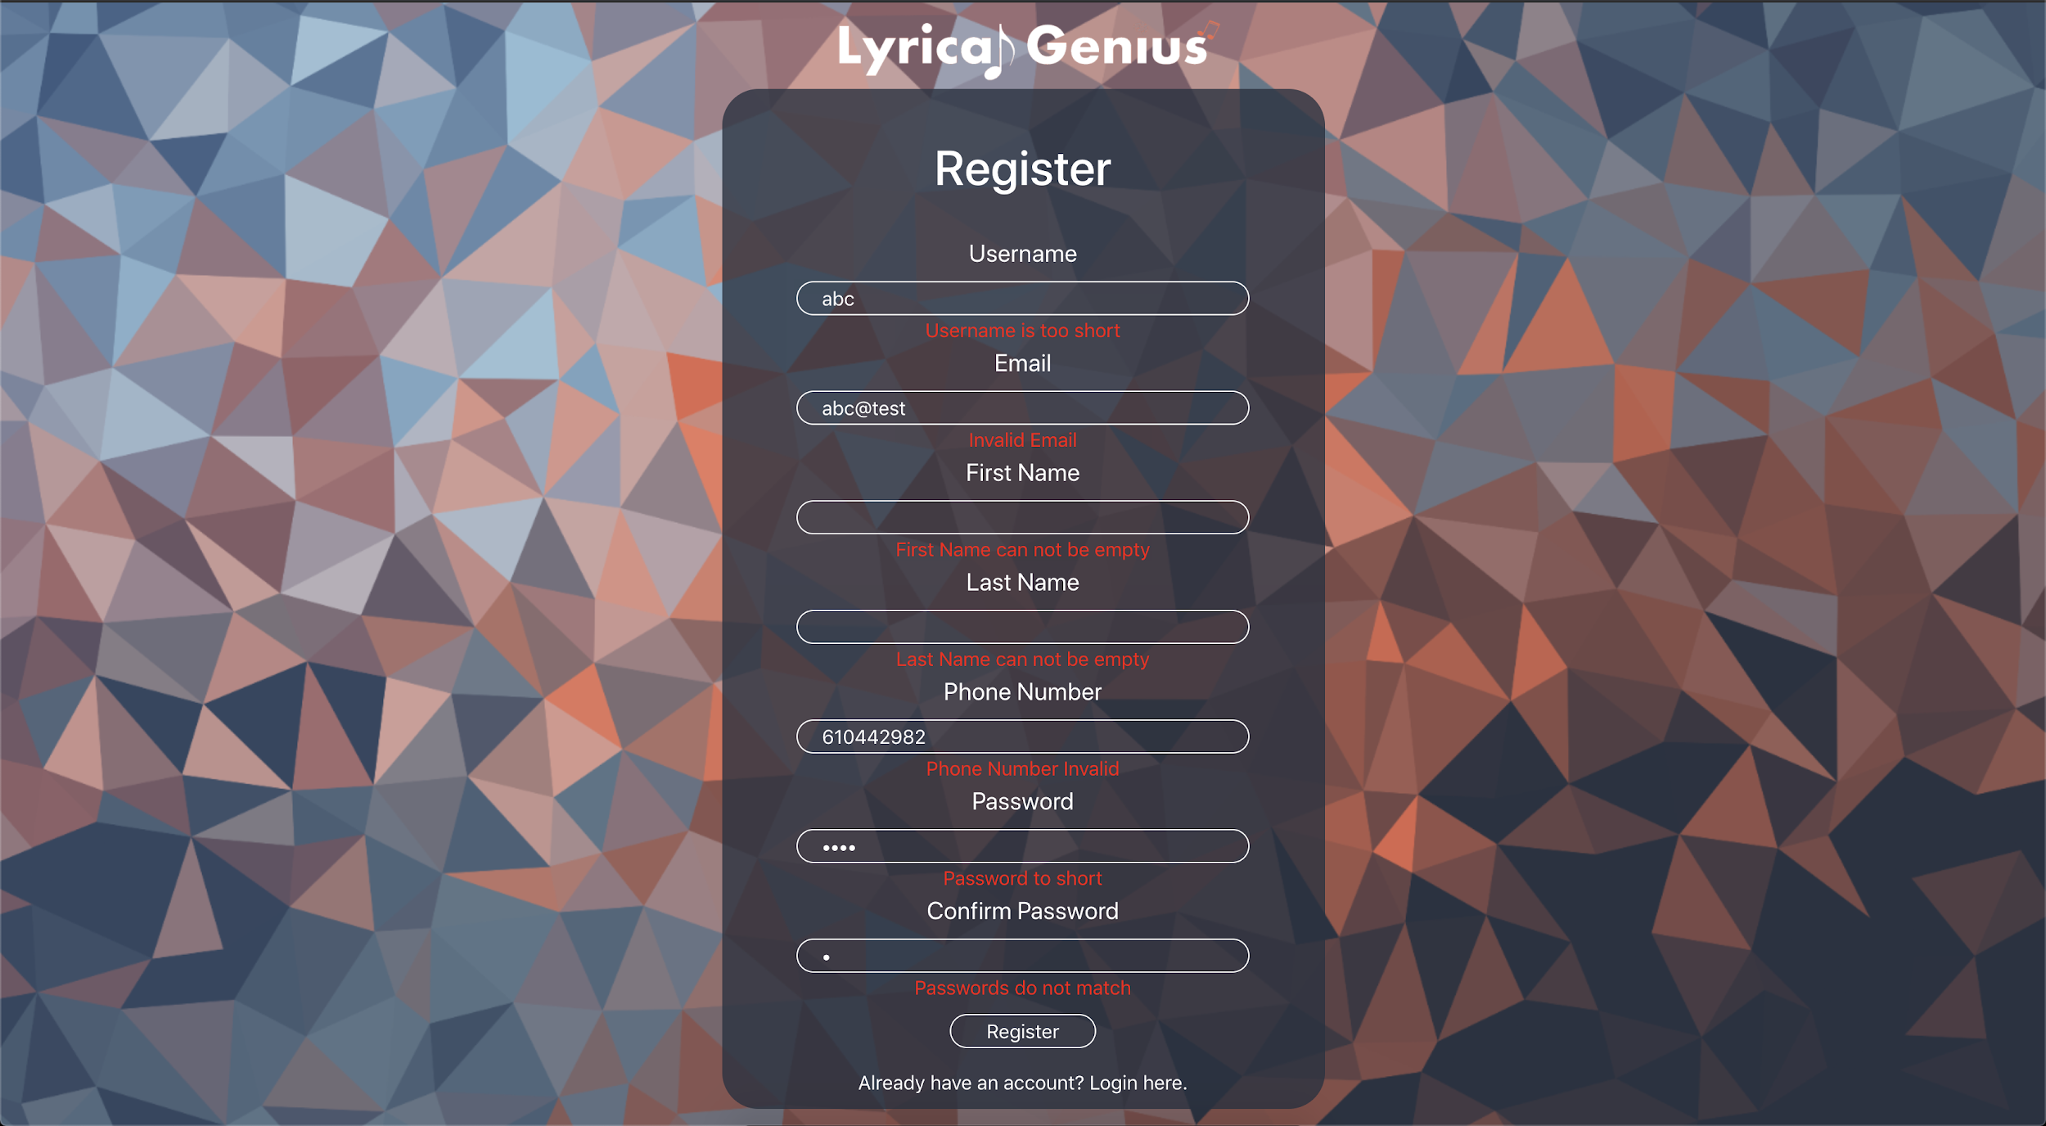

When a form is filled out and any kind of red text shows below (error) it will not permit the user to submit the form. It checks to make sure that all fields are valid.

Completed Valid Form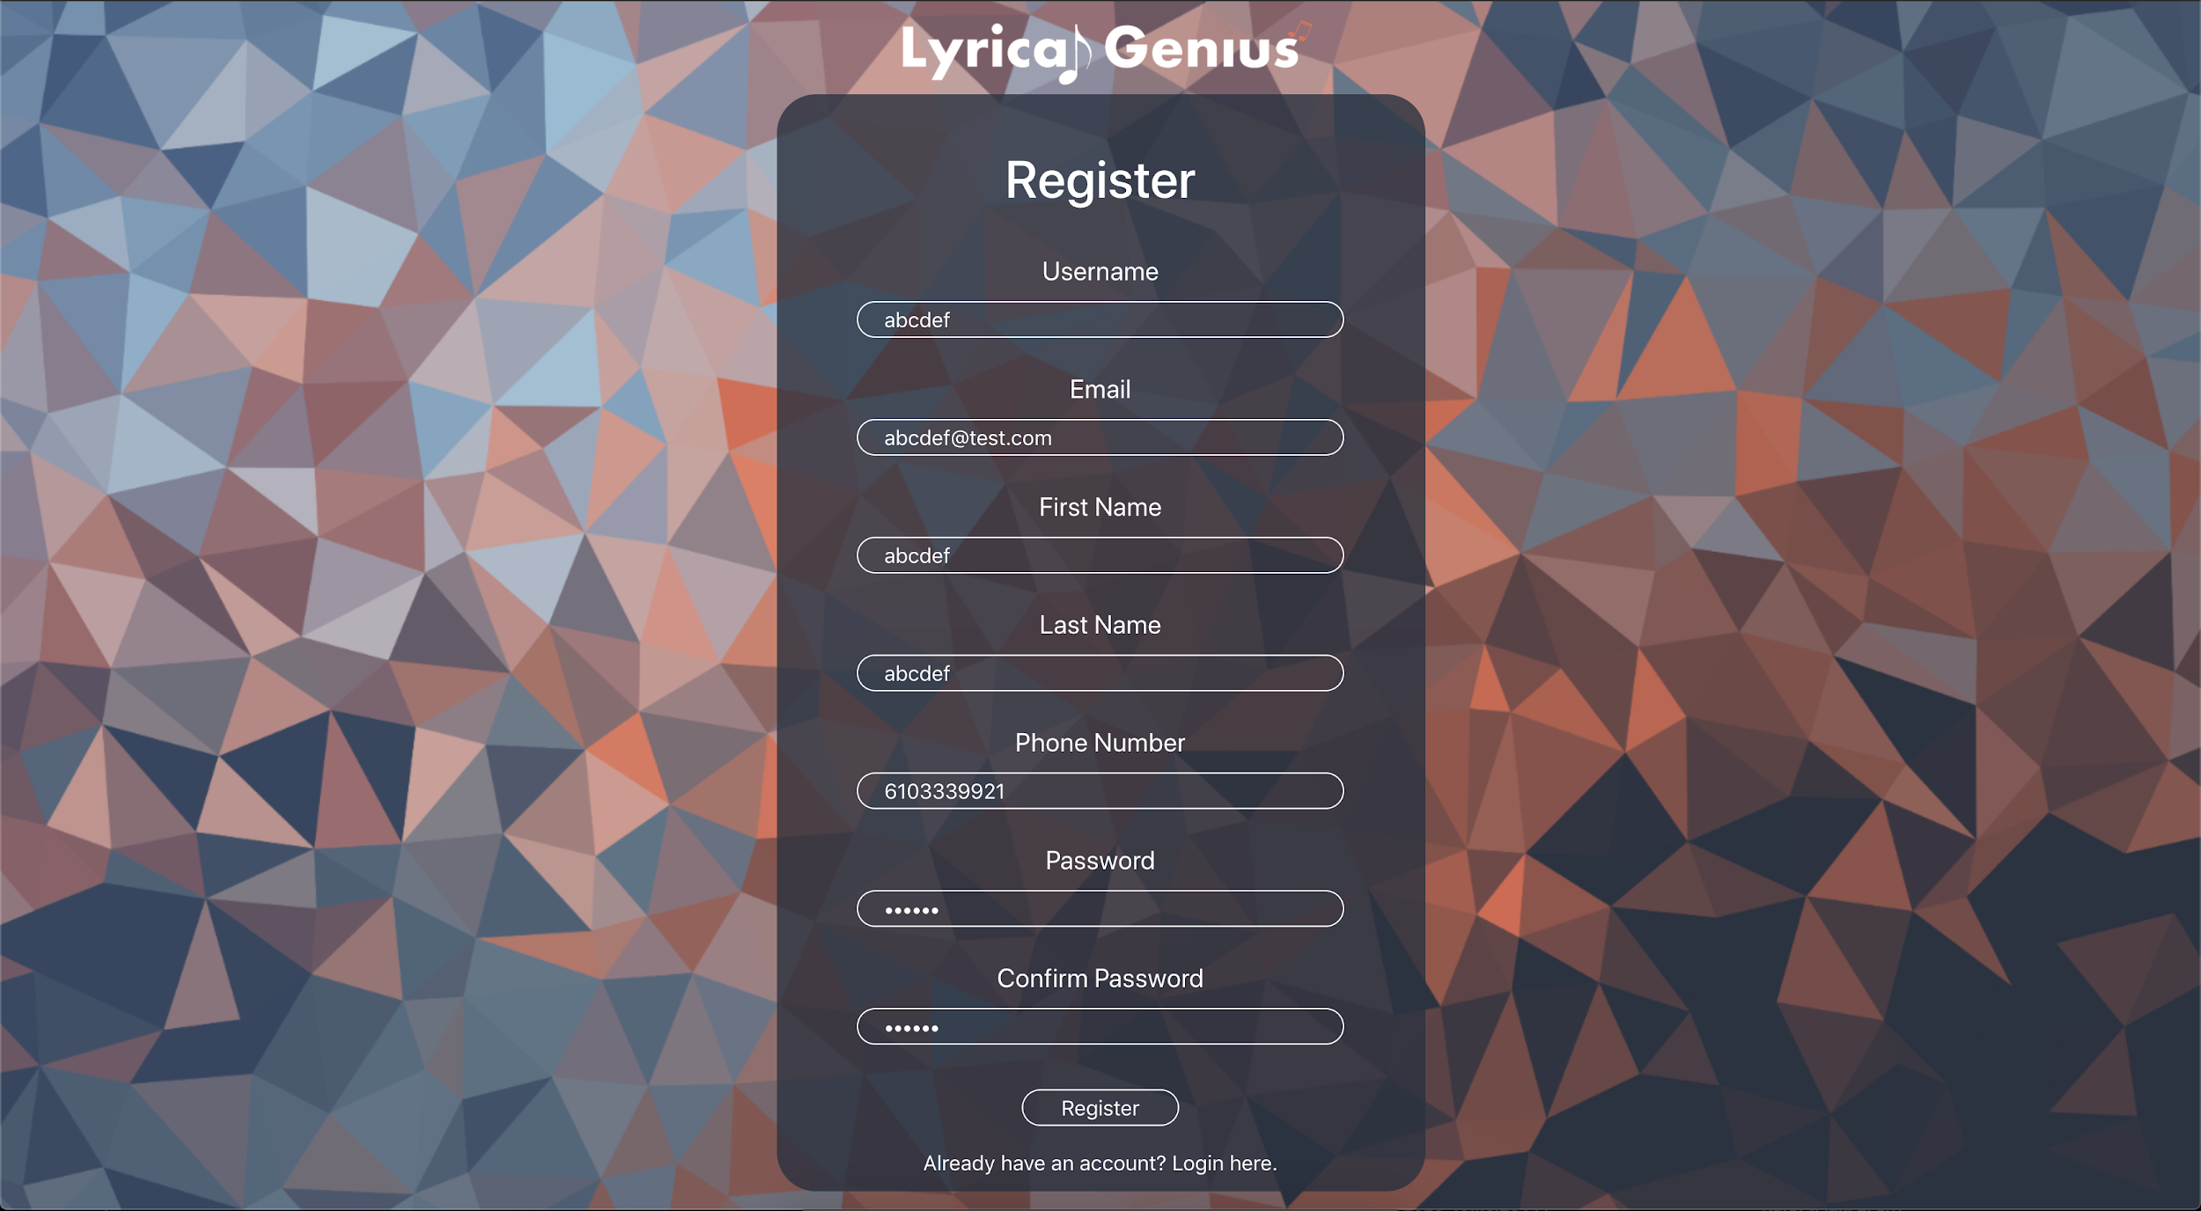

When a valid form is filled out it will not show any errors and it will allow for the form to submit. On submit it will create the account and redirect to the login page.

User In Database

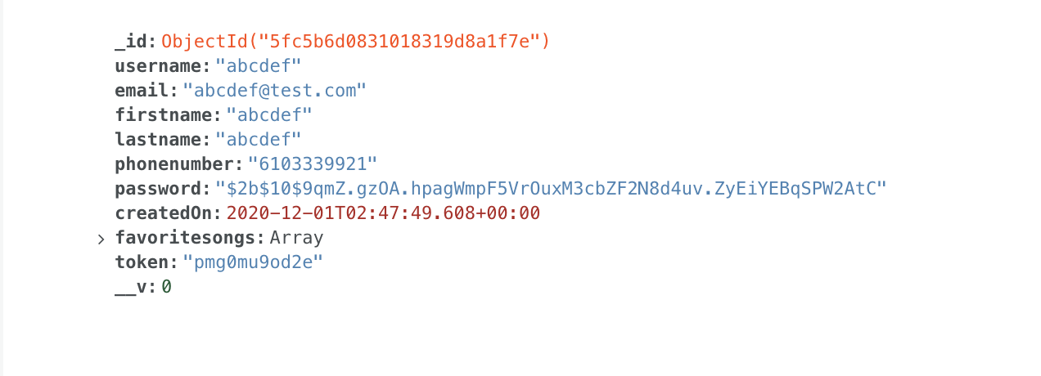

The resulting object that is created after the successful registration

Login Testing

Test Case

* Try to login with non existent user
* Try to login with incorrect password
* Valid Login

Non-existent User

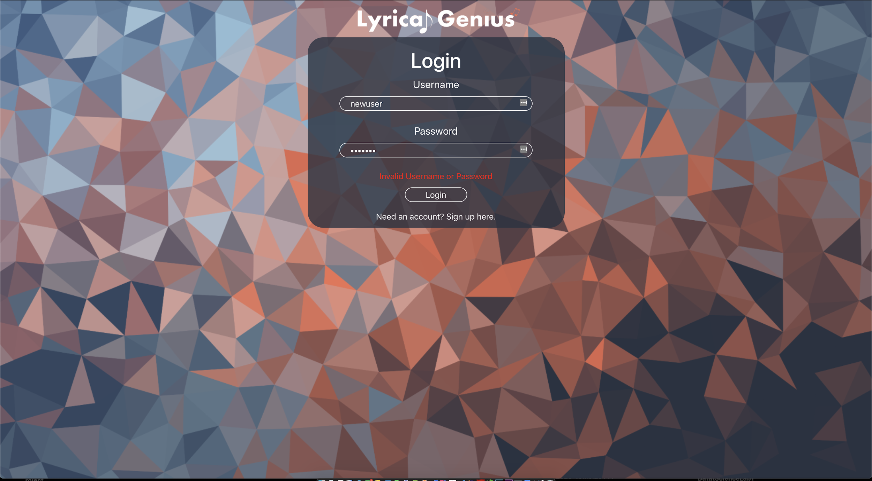

When trying to login with a username and password that is not real it will present the user with a message saying that the username or password is not incorrect.

Incorrect Password

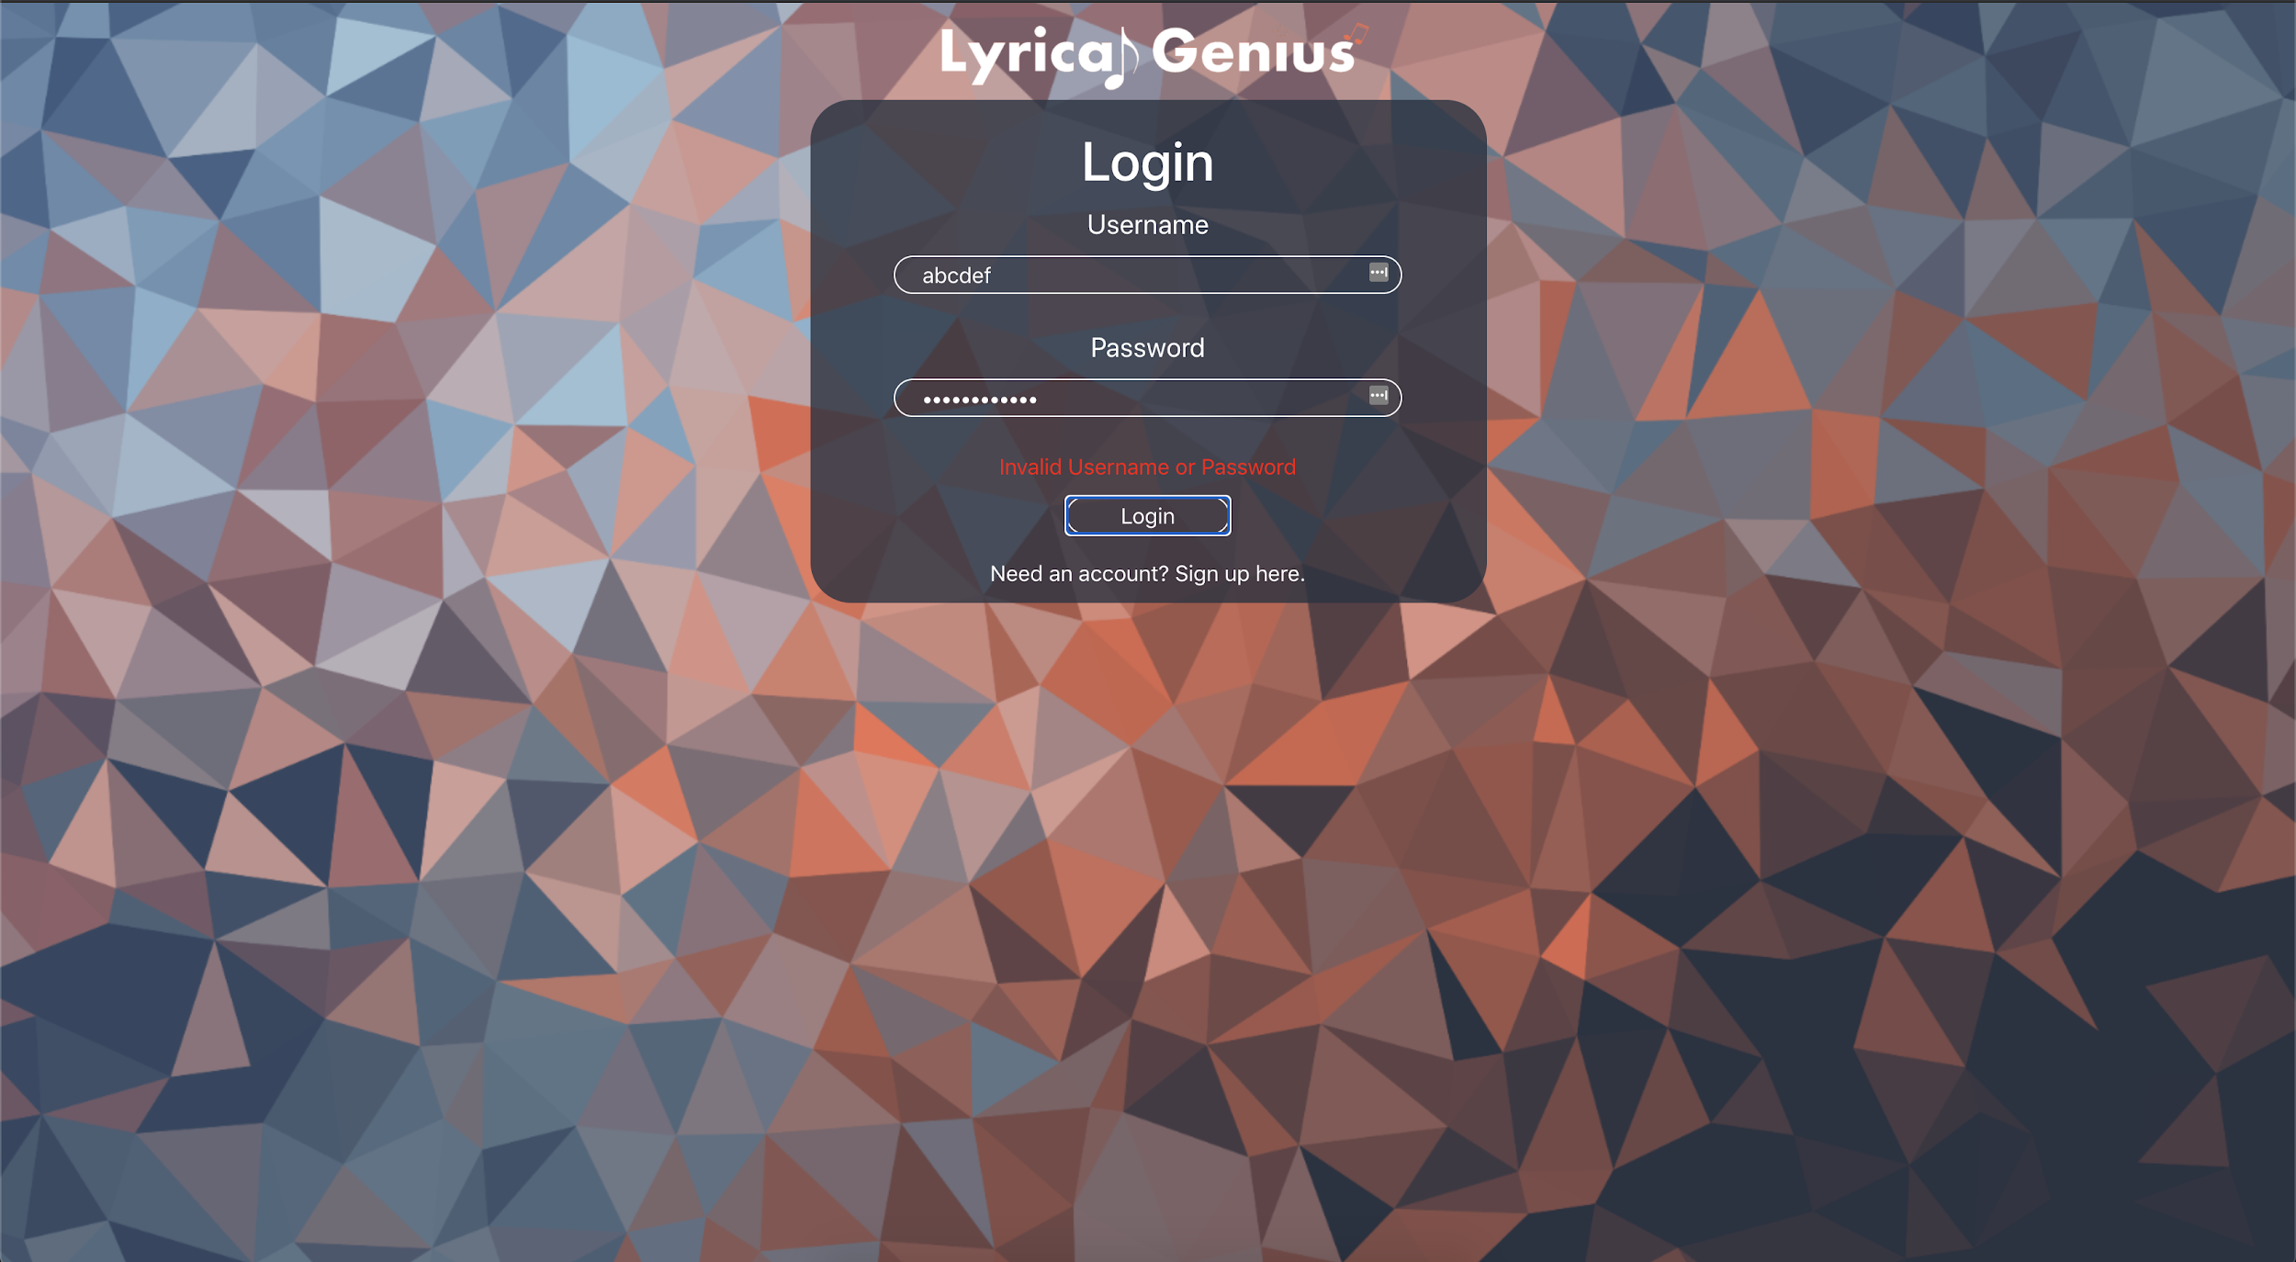

When trying to login with an account that exists but entering the wrong password it presents the user with a message saying that the username or password is incorrect and will not let them login.

Valid Login

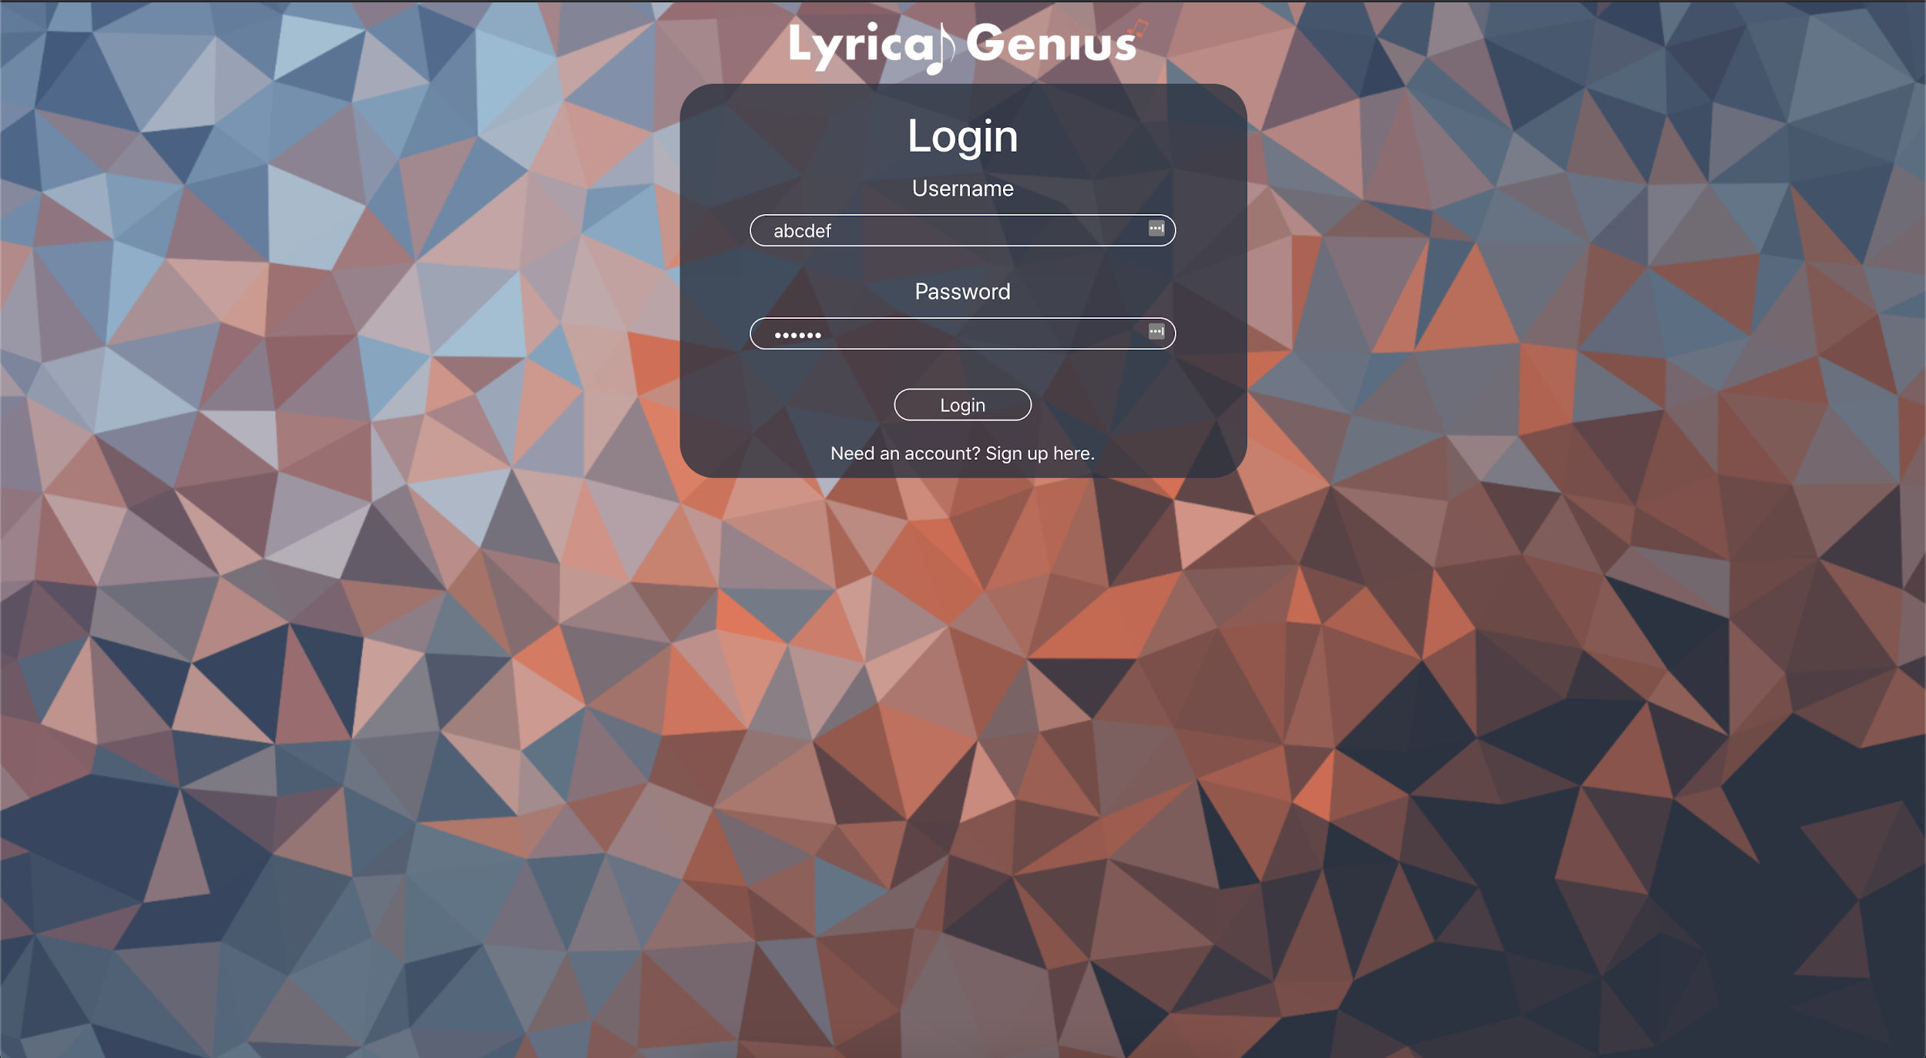

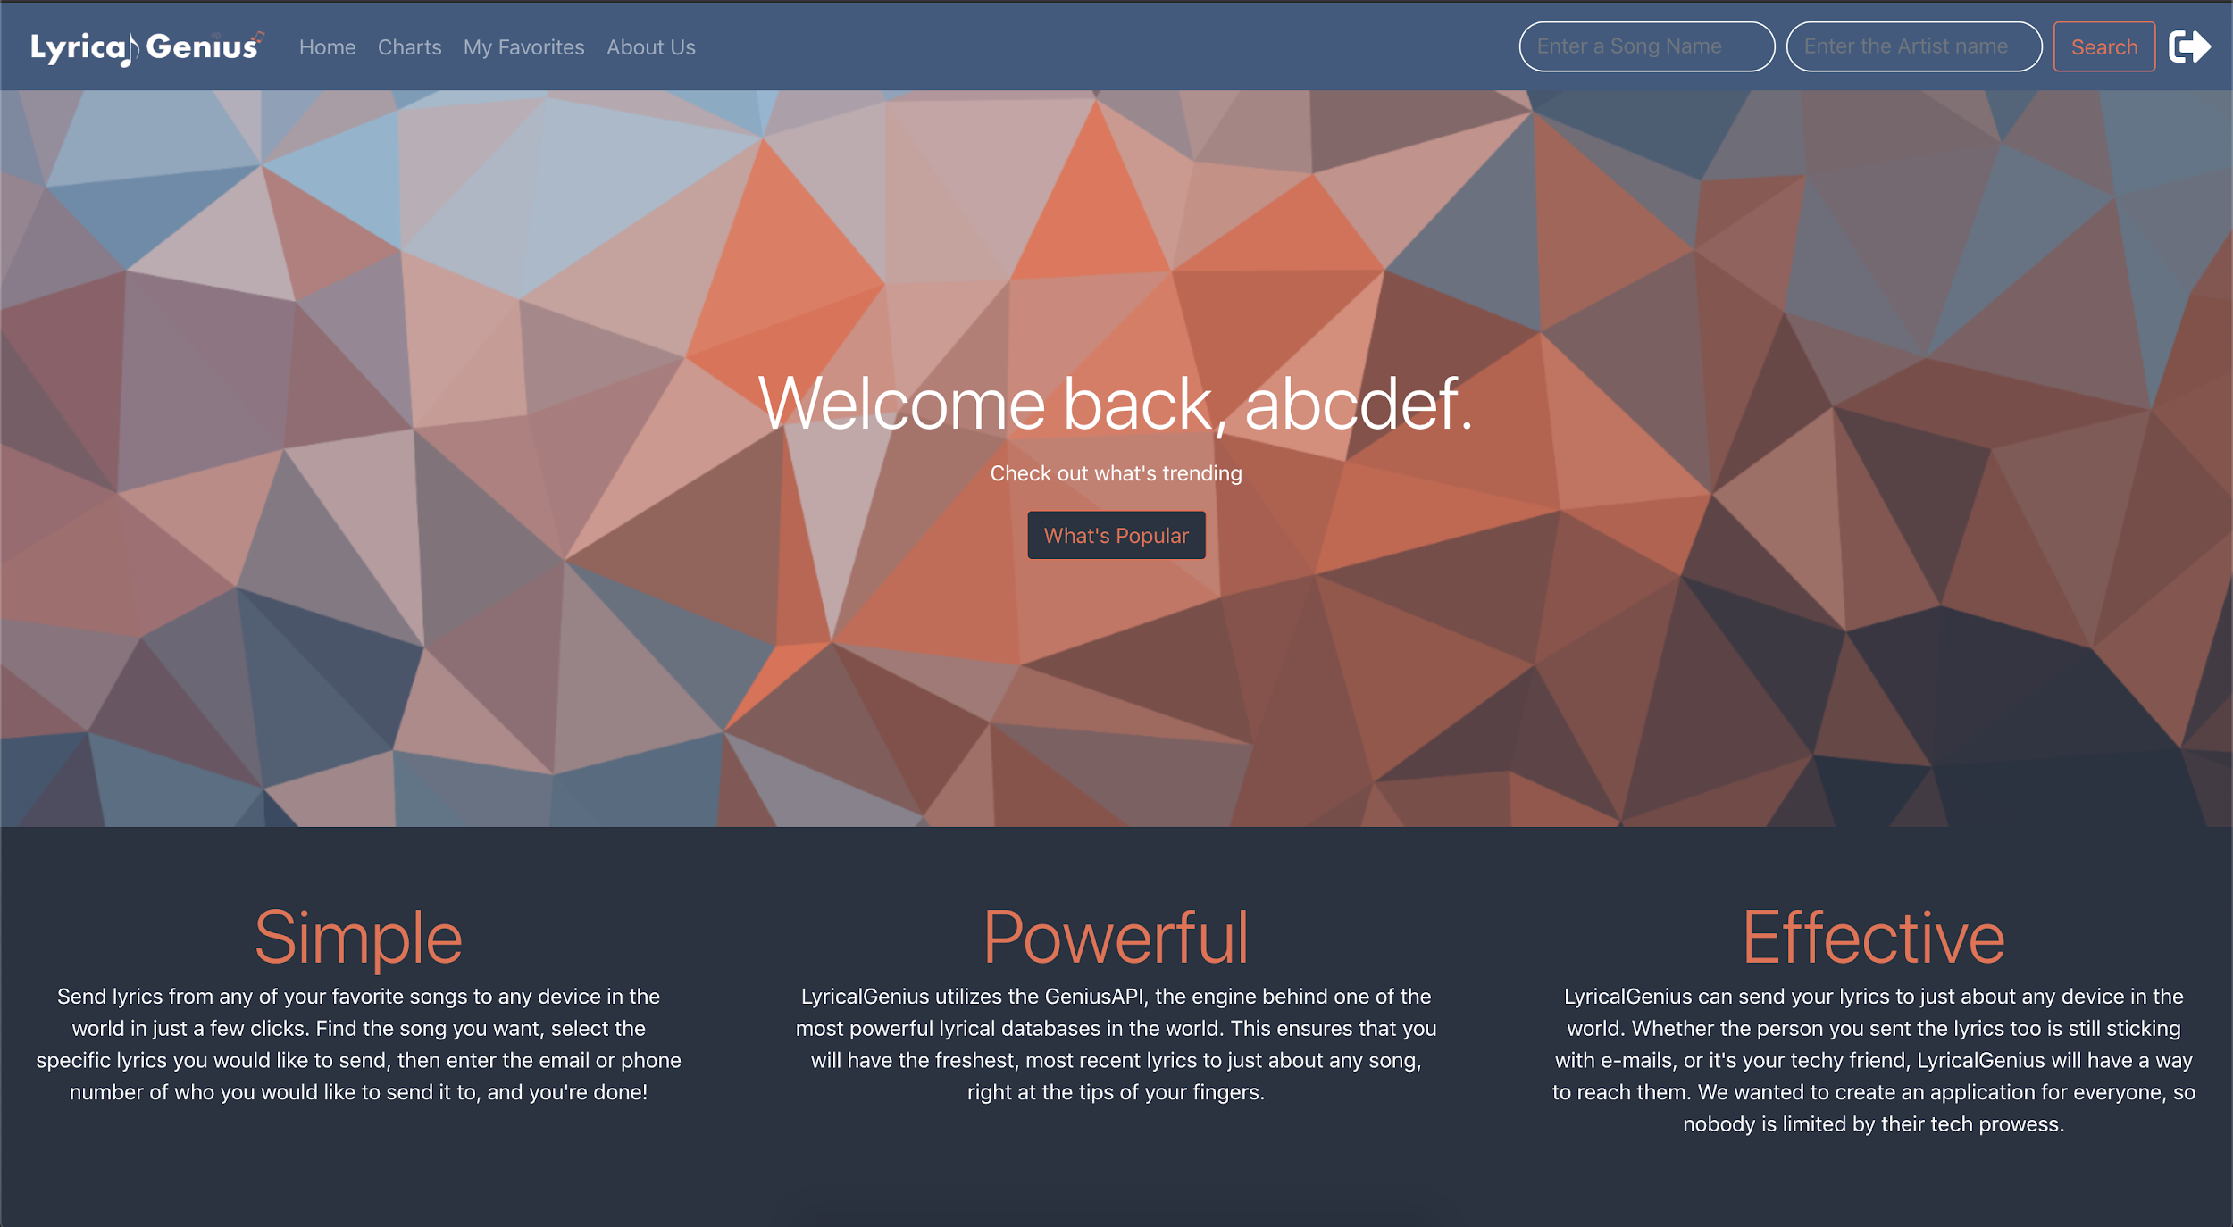

When a valid login is filled in and it is correct it will validate and then log the user in and take them to the home page.

Favorite Testing

Test Case

* Check that favorites are not populated on new account
* Try to favorite a song
* Check to make sure that favorites updated
* Try to unfavorite a song
* Check to see that favorites updated

Check Favorites New Account

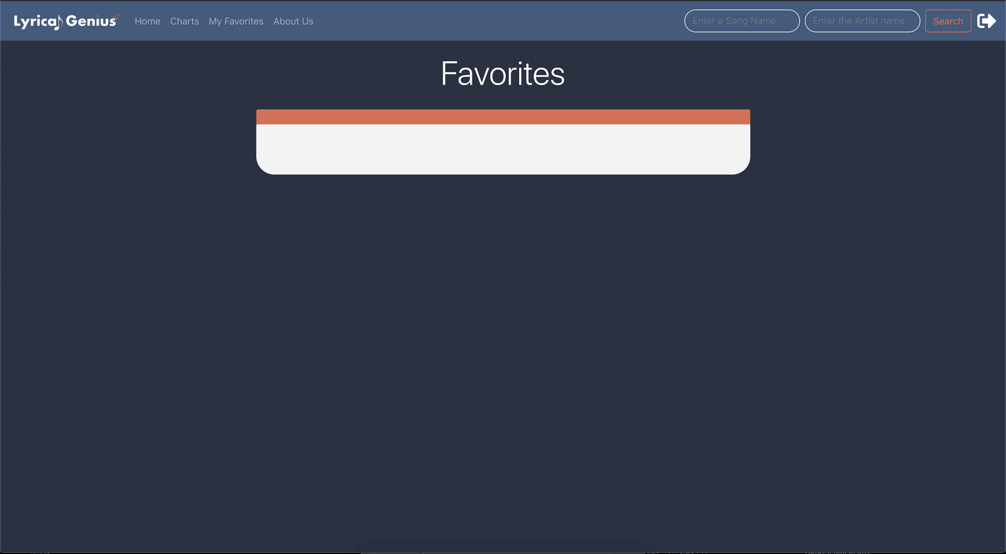

When first logging into a new account and checking the favorites it is empty as expected as they have not added any songs yet

Favoriting a Song

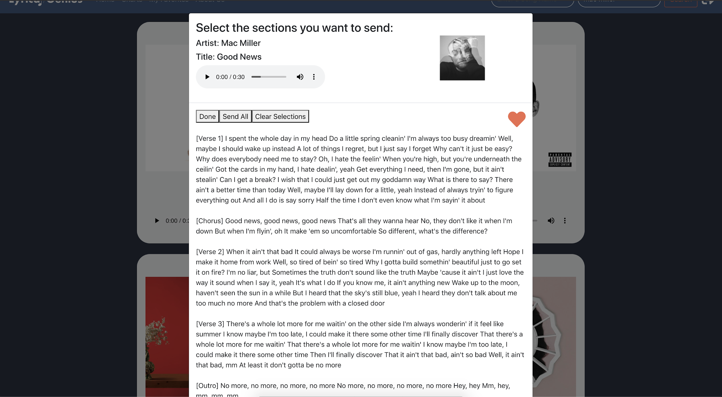

By clicking the heart it will turn red and it will signify that the song has been added to favorites. If the card is closed and reopened the color change of the heart will persist.

Make sure Favorites was Updated

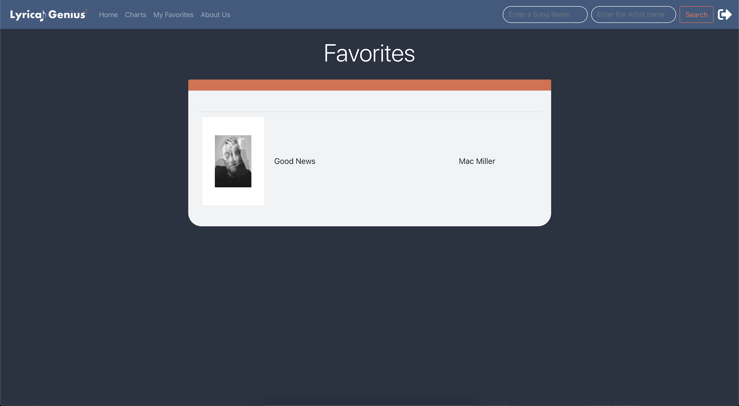

After it is favorited by going to favorites we can see that the song was added and displayed.

Unfavorite

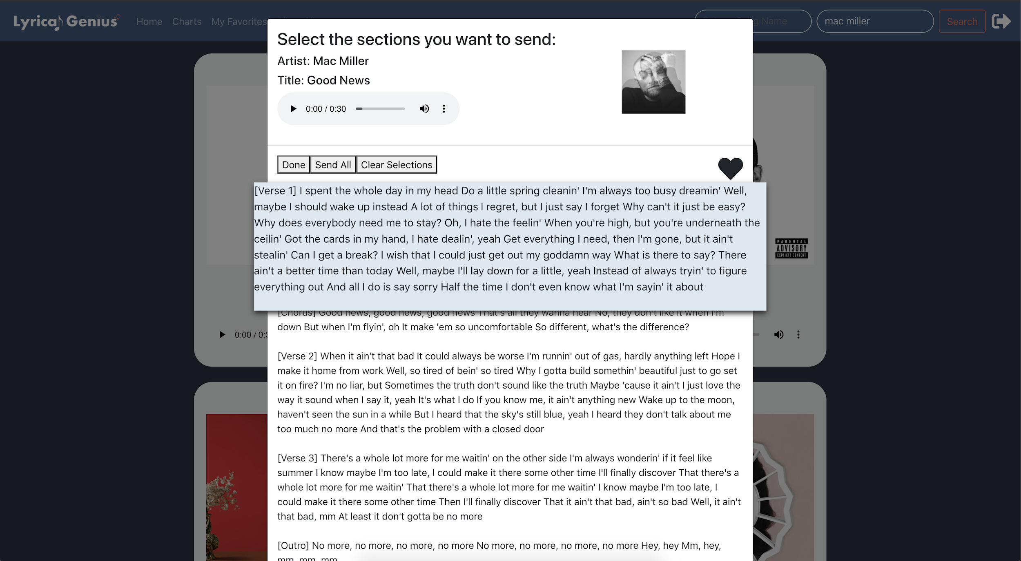

By clicking the heart again it will turn black and then the song will be unfavorited. If the card is reopened the change will persist

Check Favorites Updated

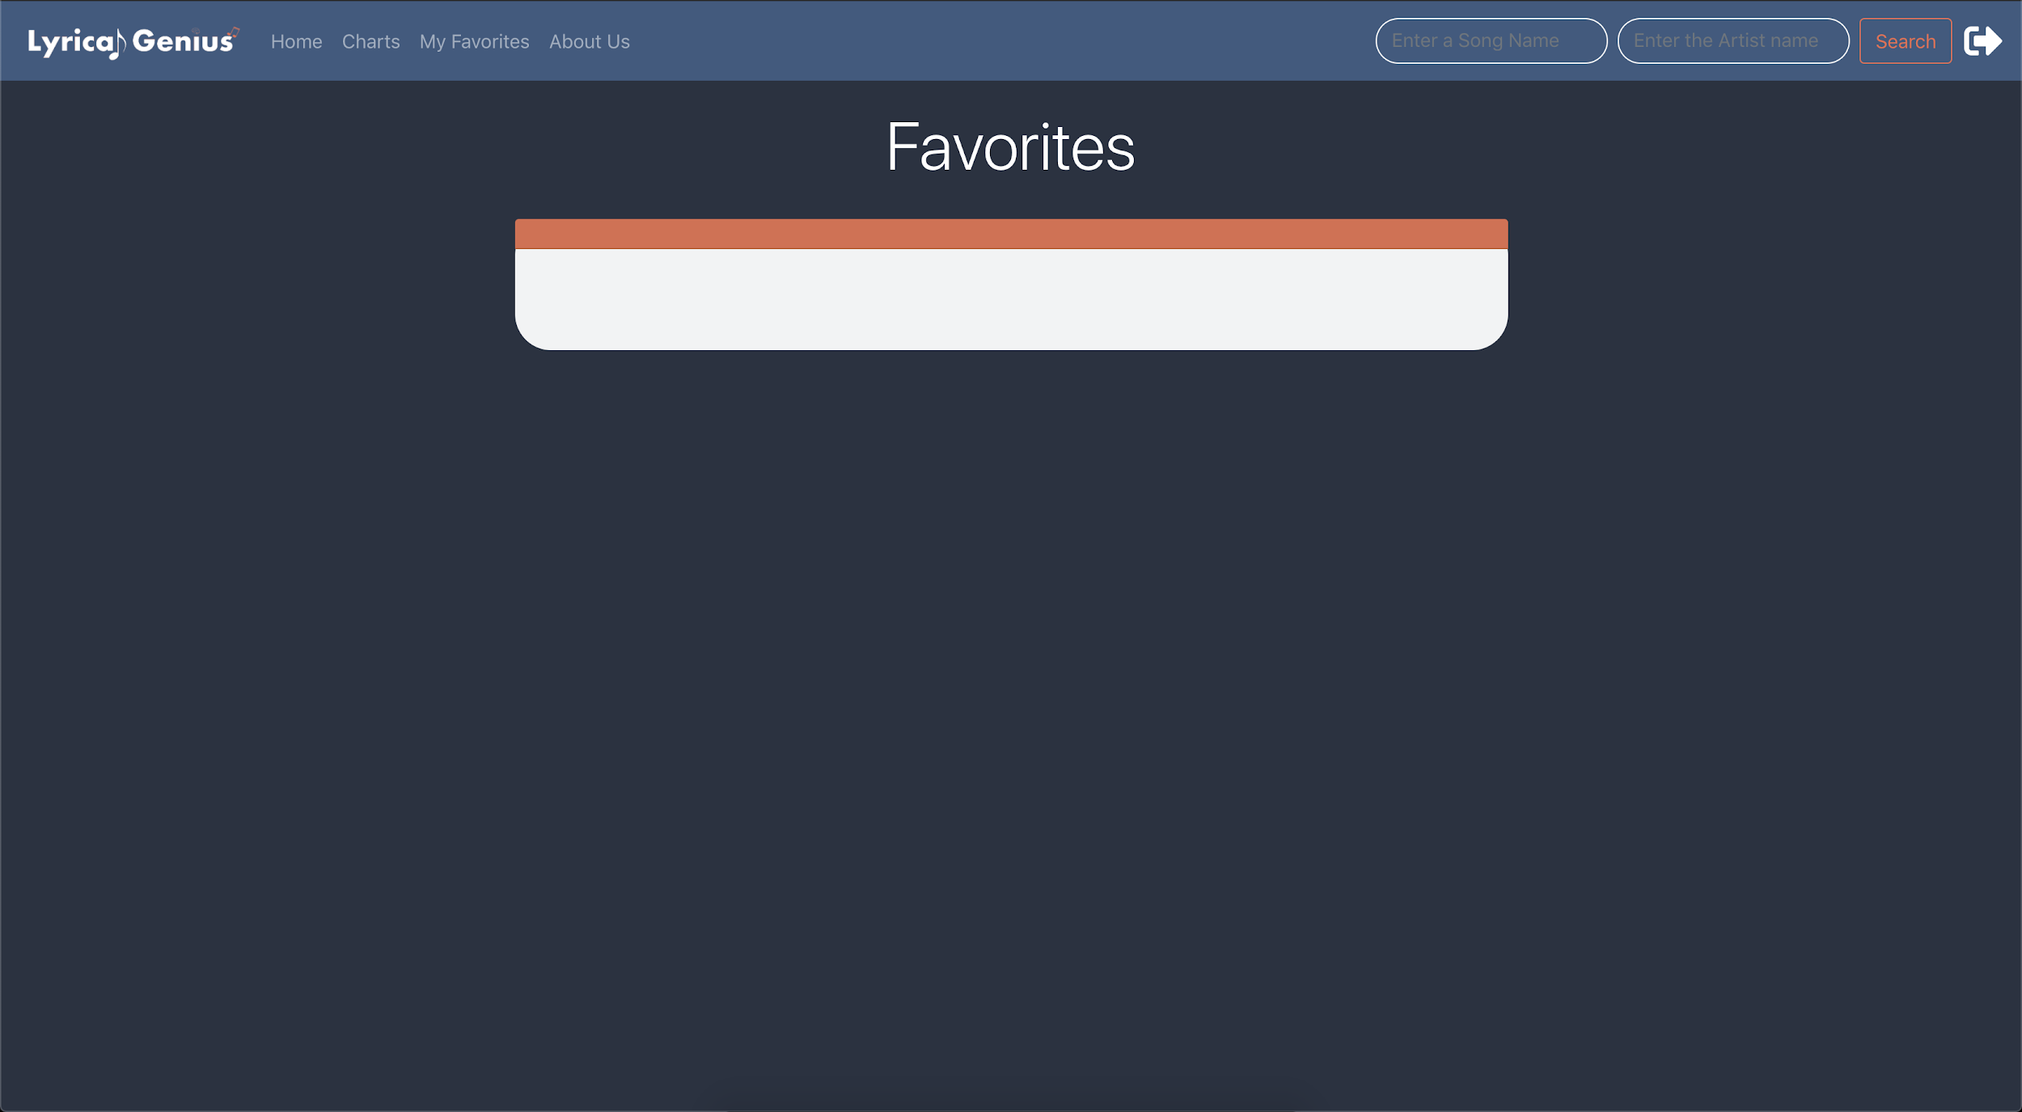

Going back to favorites after we unfavorited the song we can see that it is once again empty.

Chart Testing

Test Case

* Make sure a search updates the chart

*Search is dependent on is entirety of the search (artist, song) so the updates are based on that as well

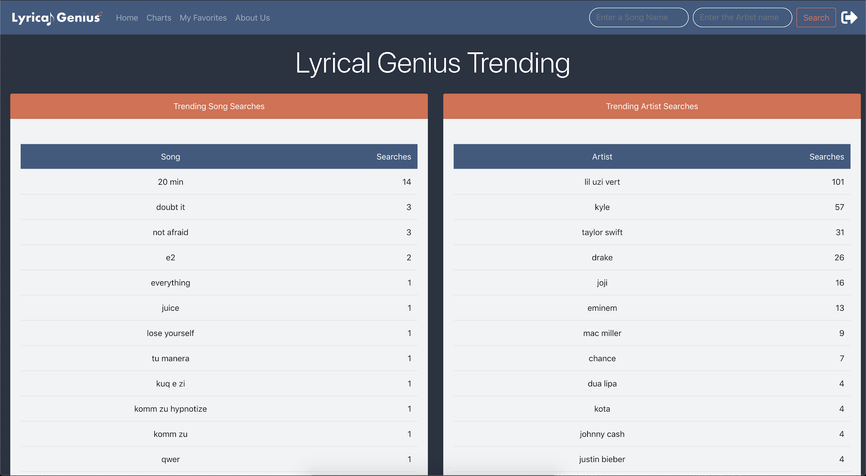

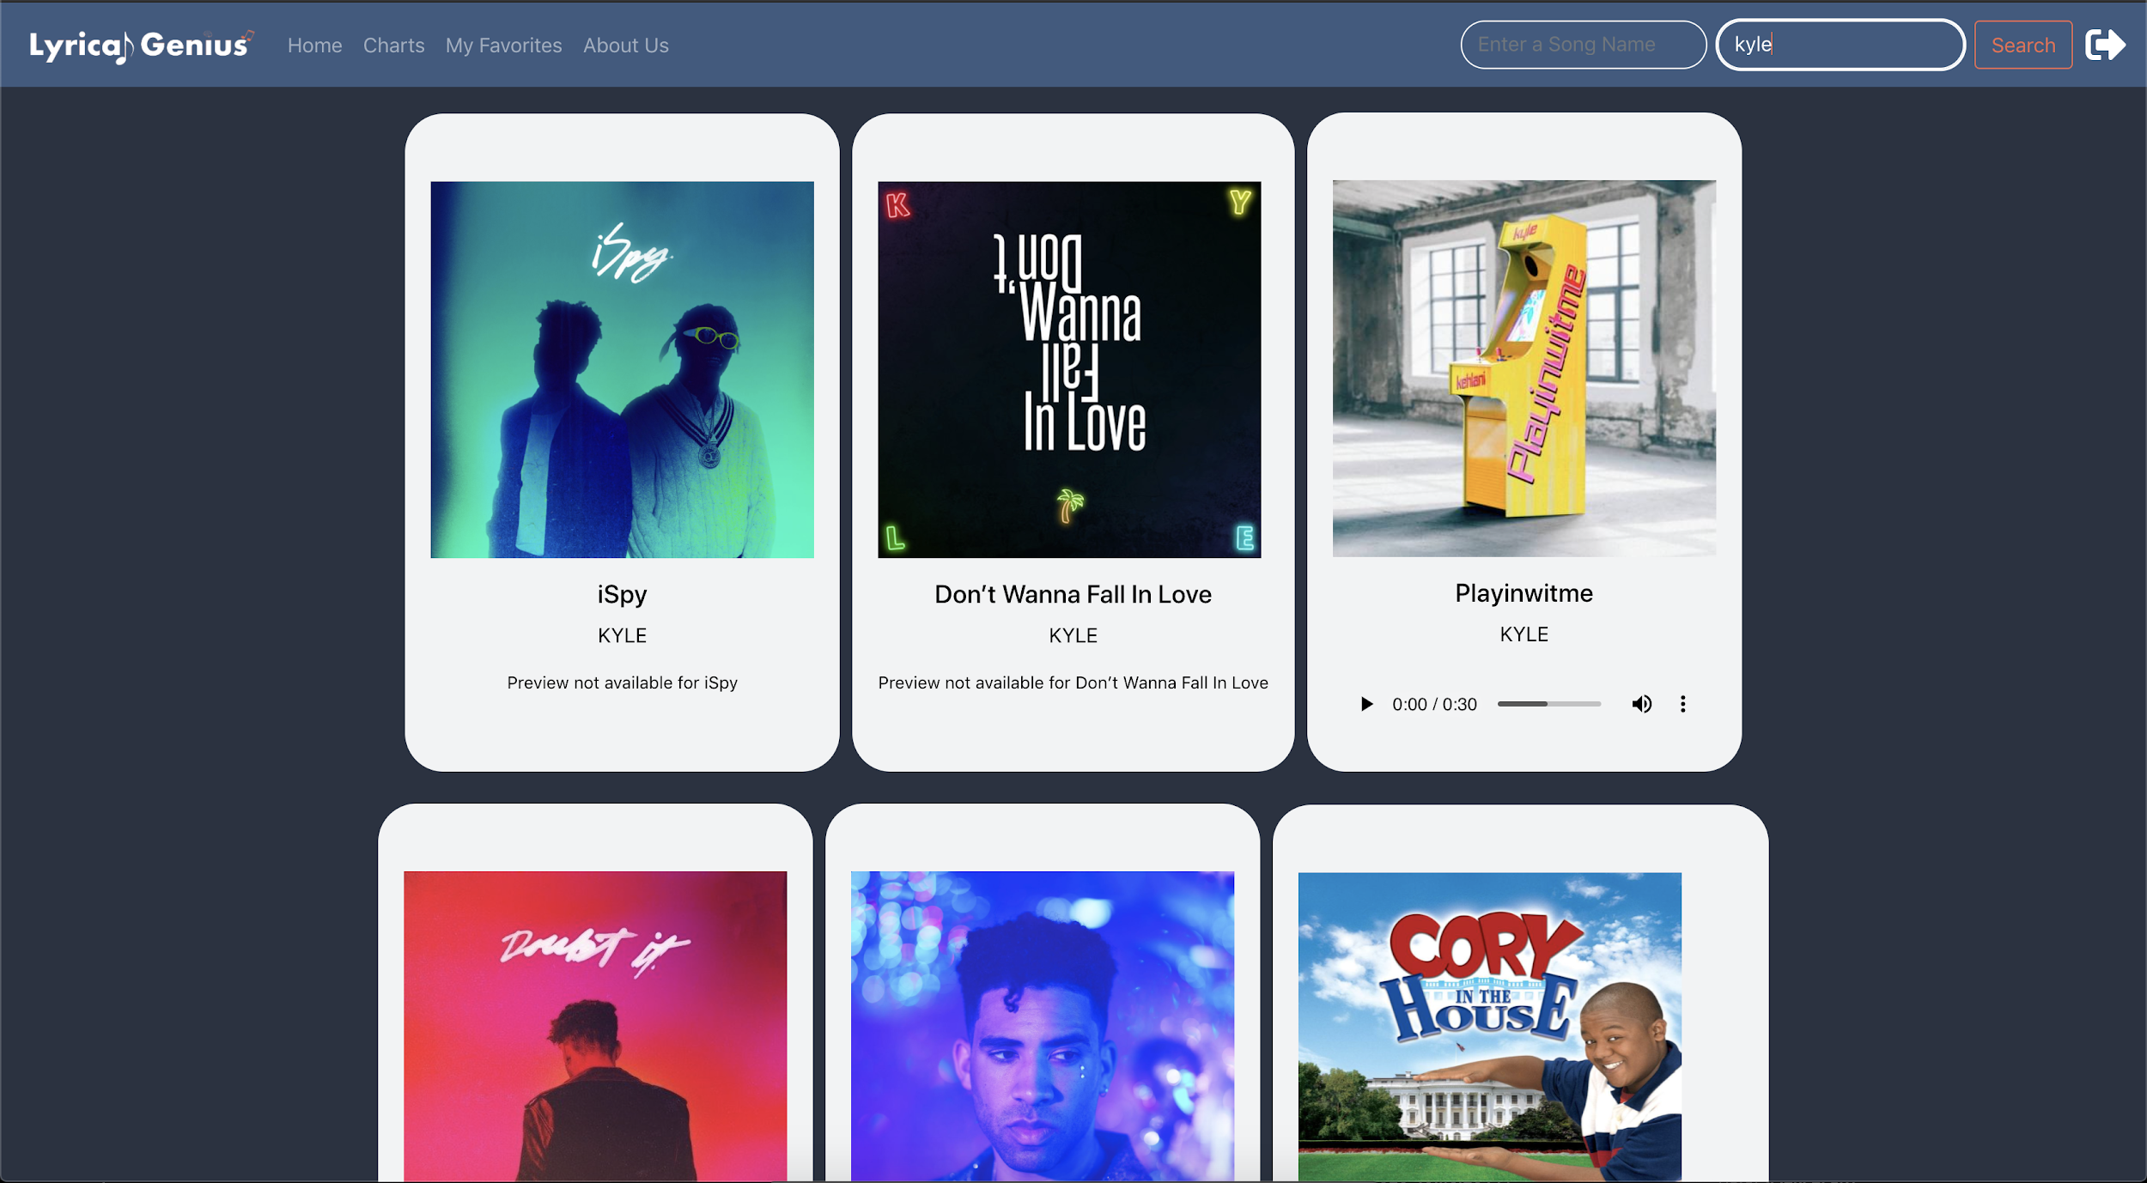

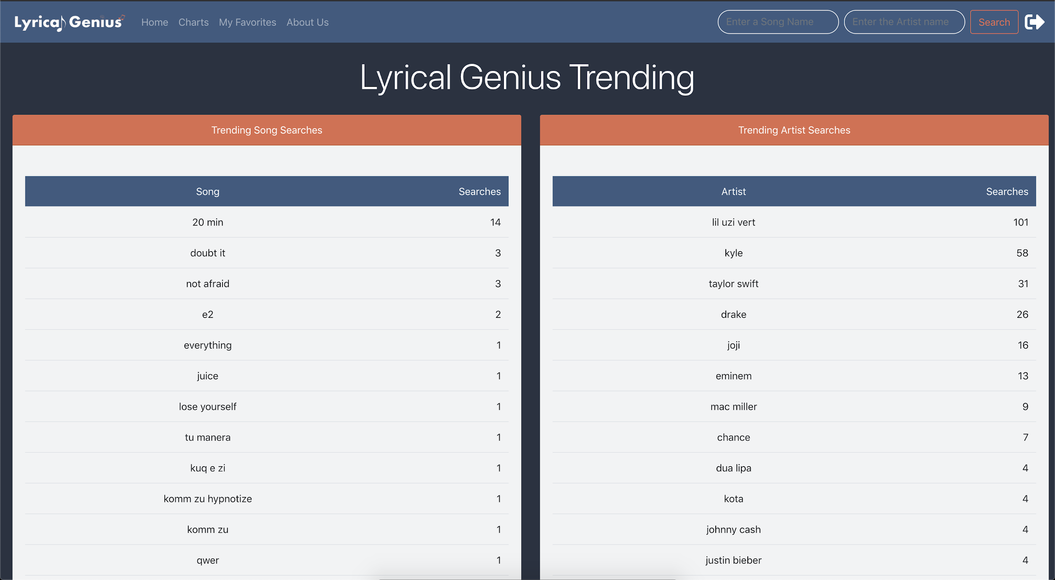

In the first picture for artist we can see that kyle has 57 searches. Then after another search shown in the second picture we can see in the last that the count went up by 1 to 58.

Resolution Testing

Test Case

* Access every page in desktop resolution
* Access every page in mobile resolution

Signup

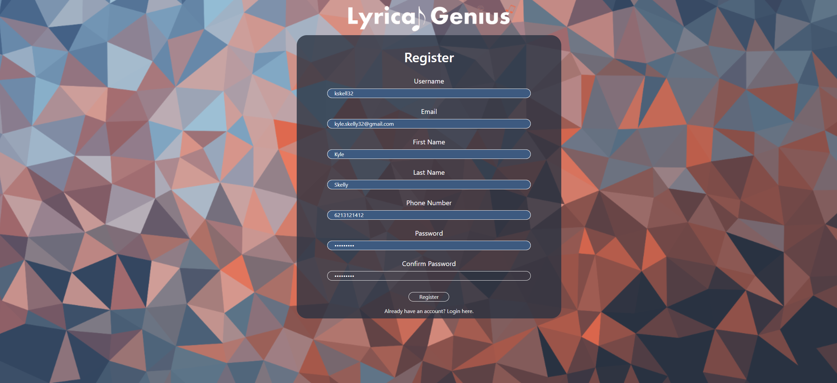

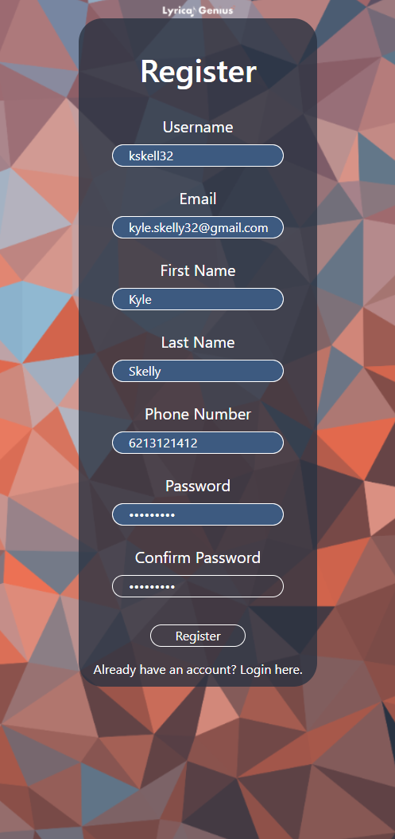

Login

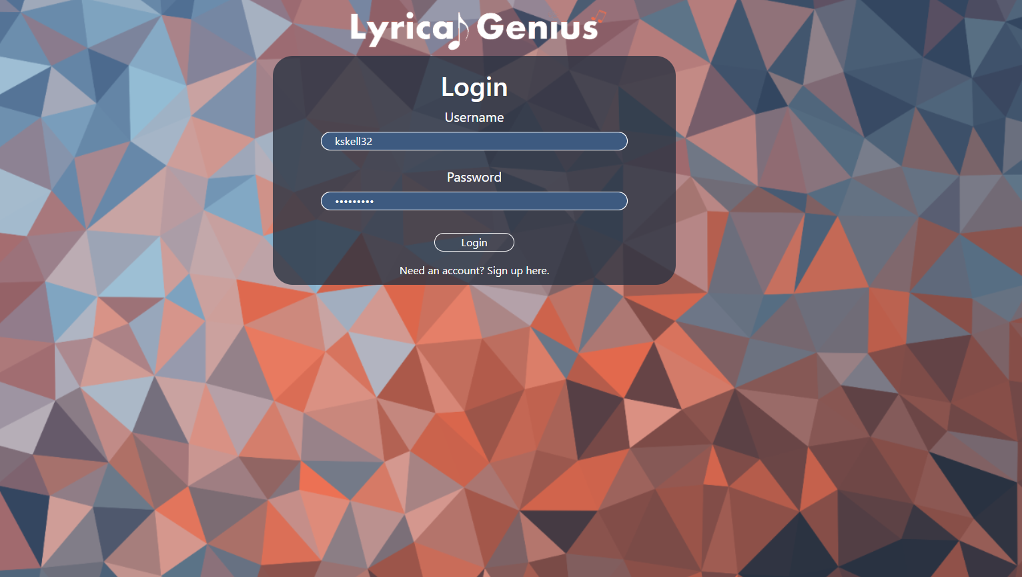

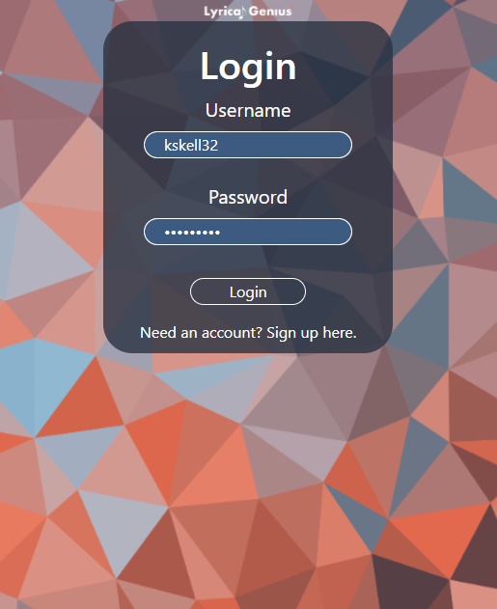

Home Page

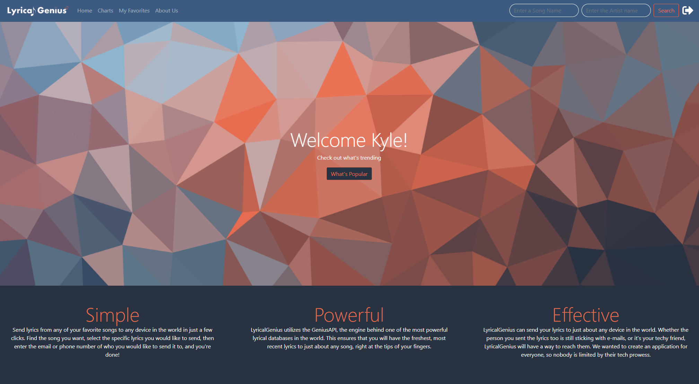

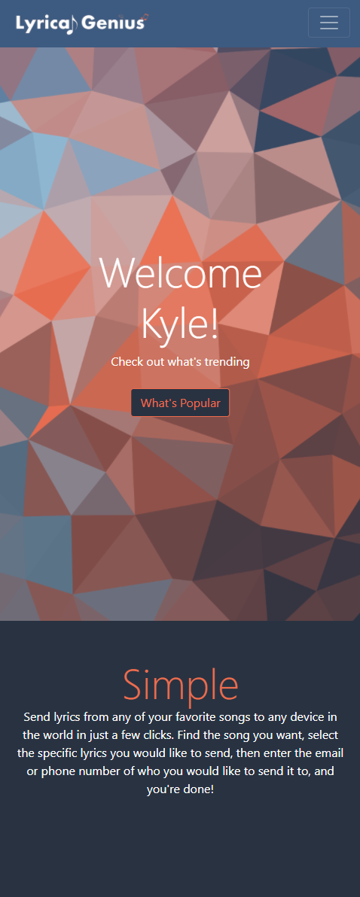

Home with Navbar dropdown (mobile)

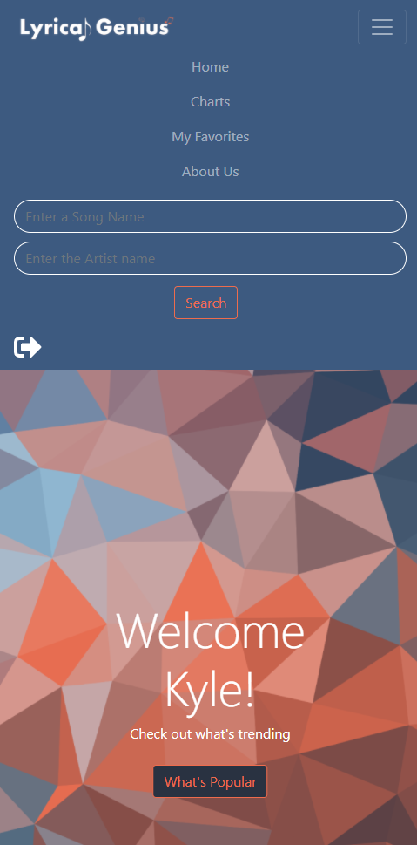

Charts

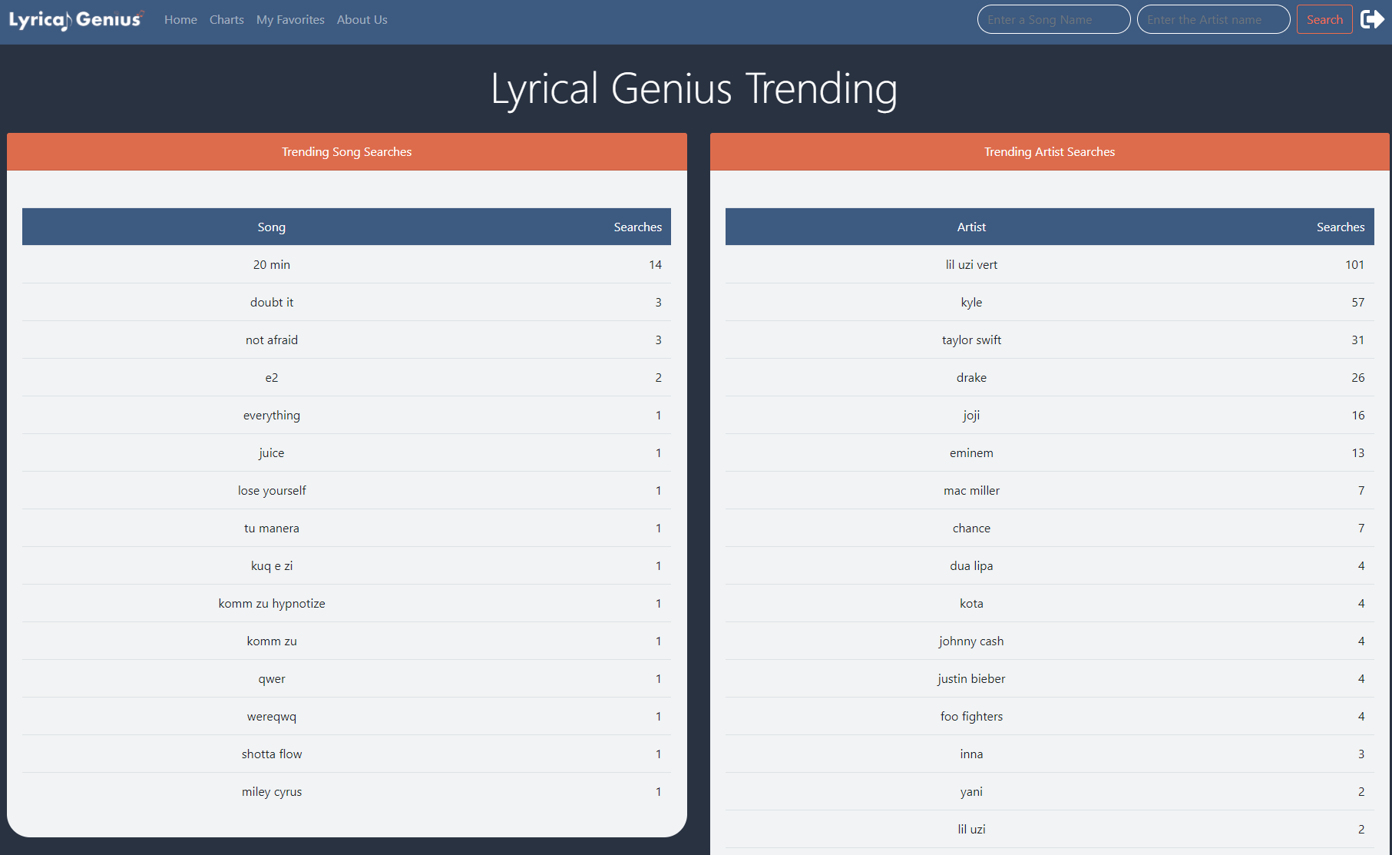

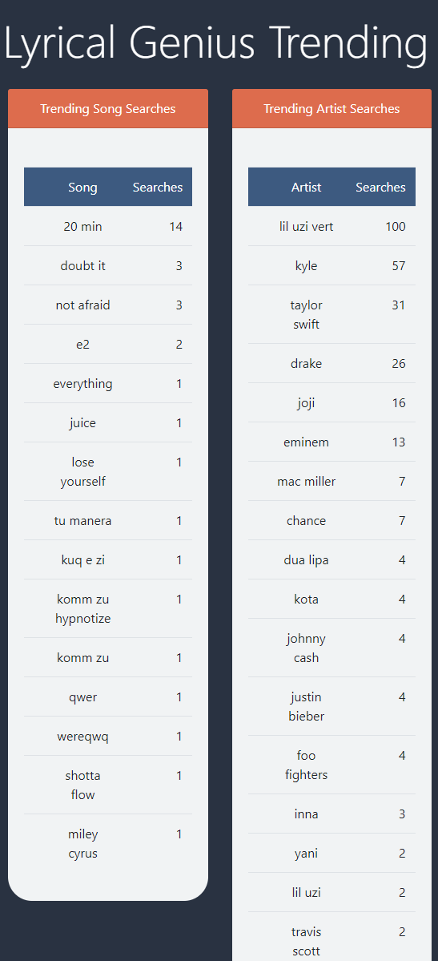

About Us





Favorites

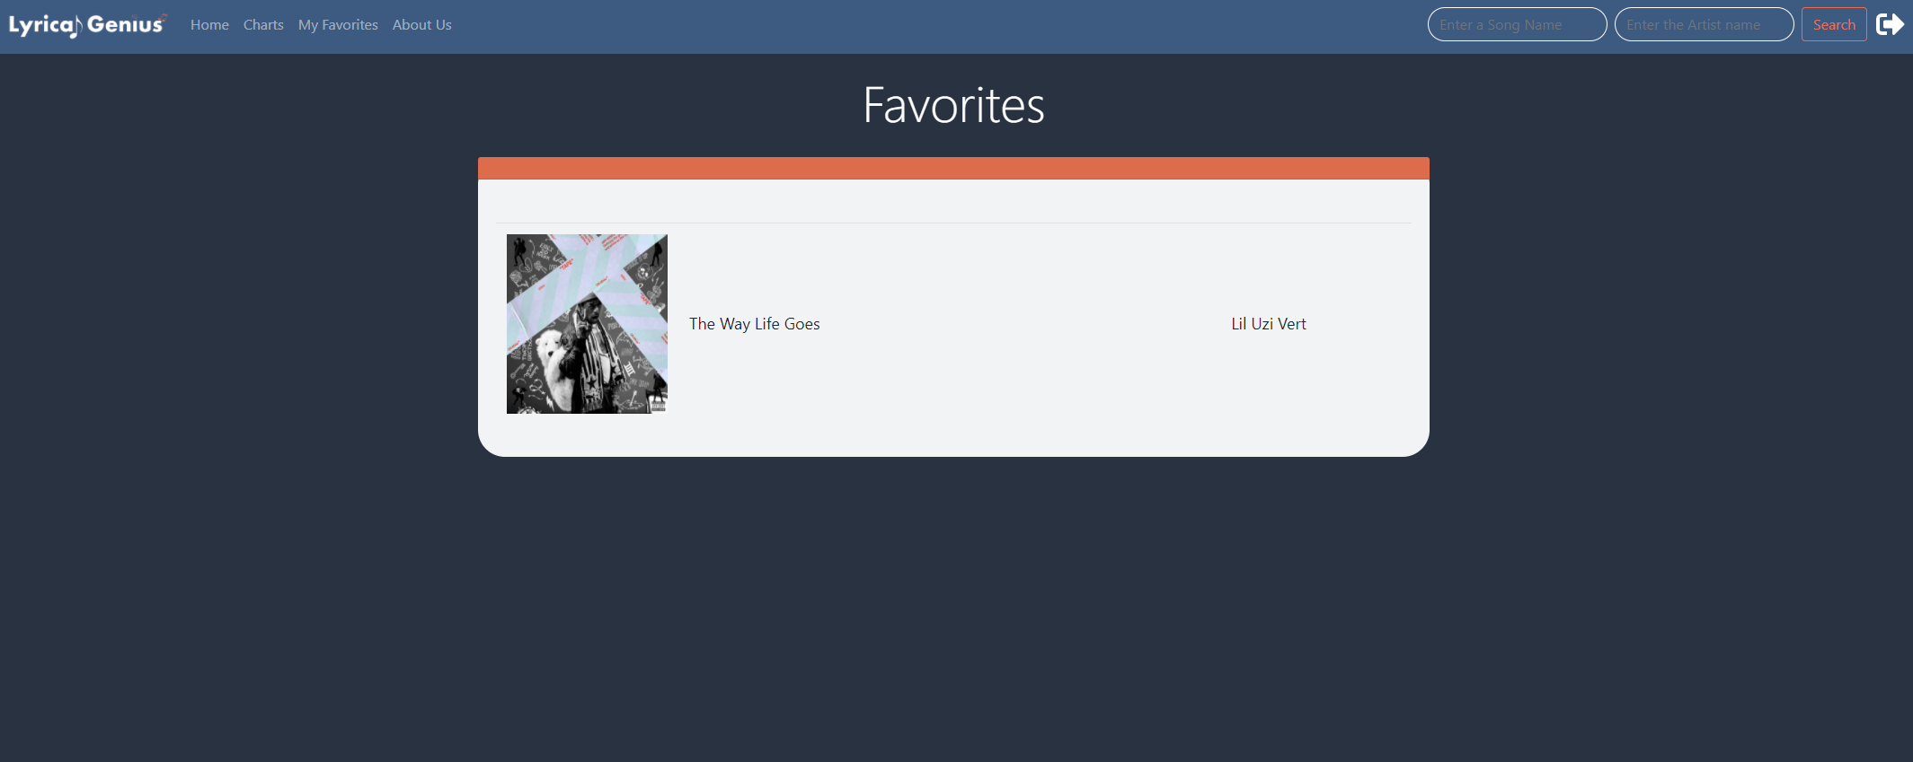

* 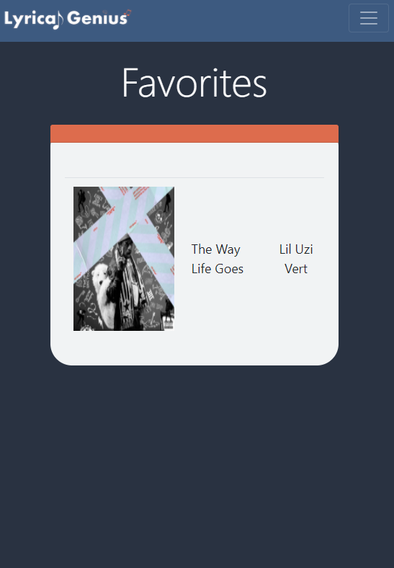

**First Modal Testing**

When the user does not select an option before clicking done, a timed toast pops up advising them to select an option.

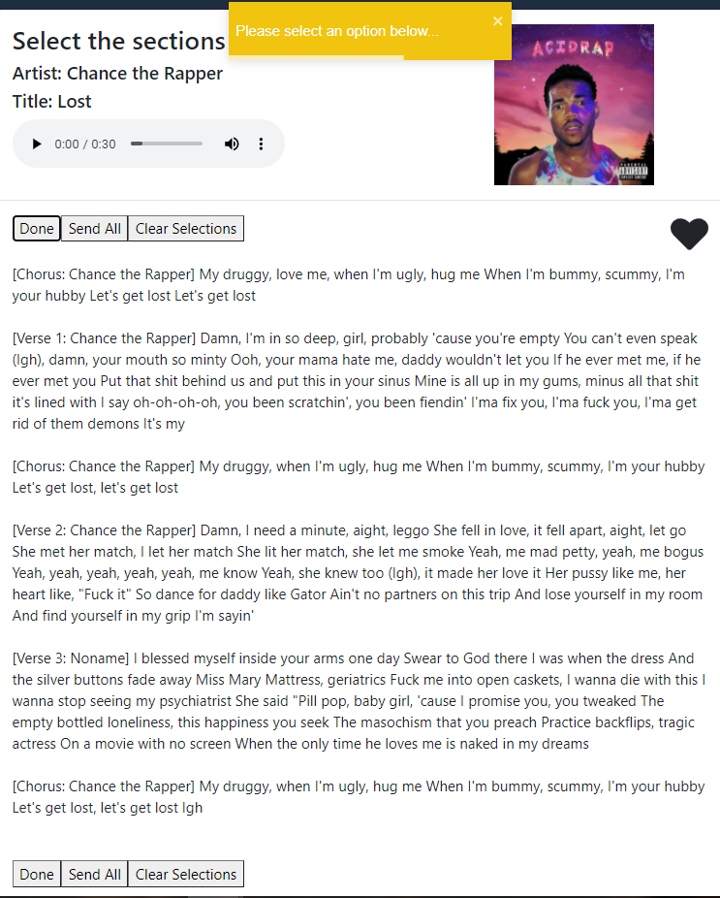

Hovered list items are zoomed in, clicked items are highlighted, unclicked items have their background-color converted back to #fff

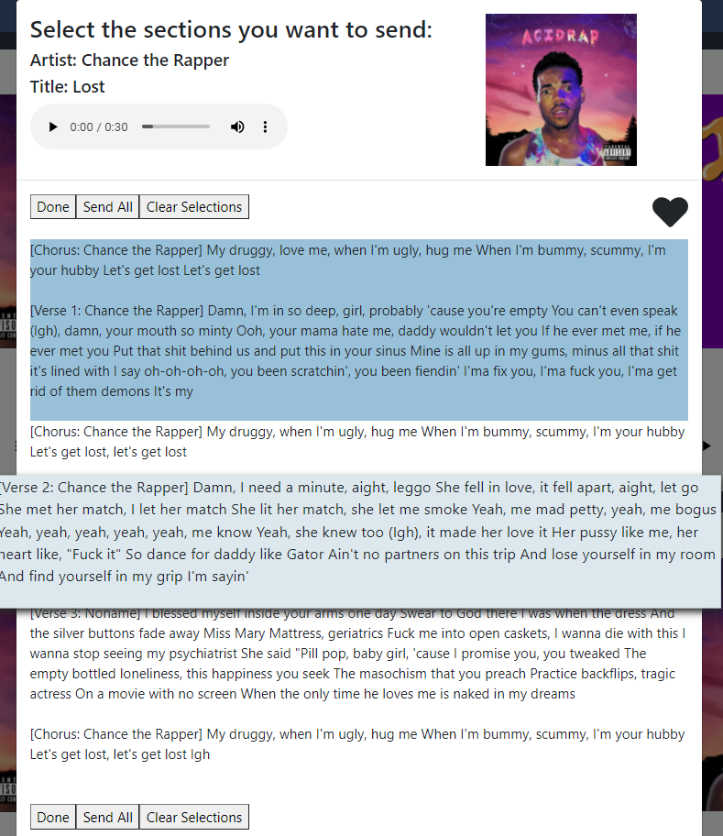

**Second Modal Testing**

Invalid Input Test:

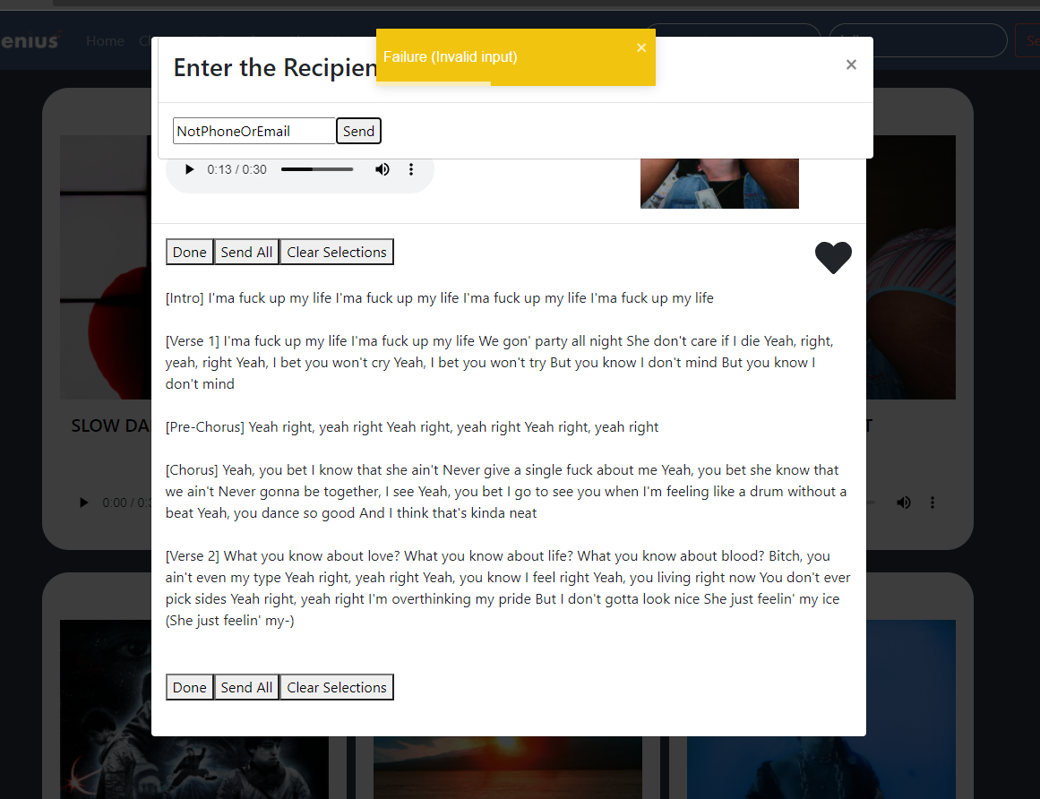

Email Test:

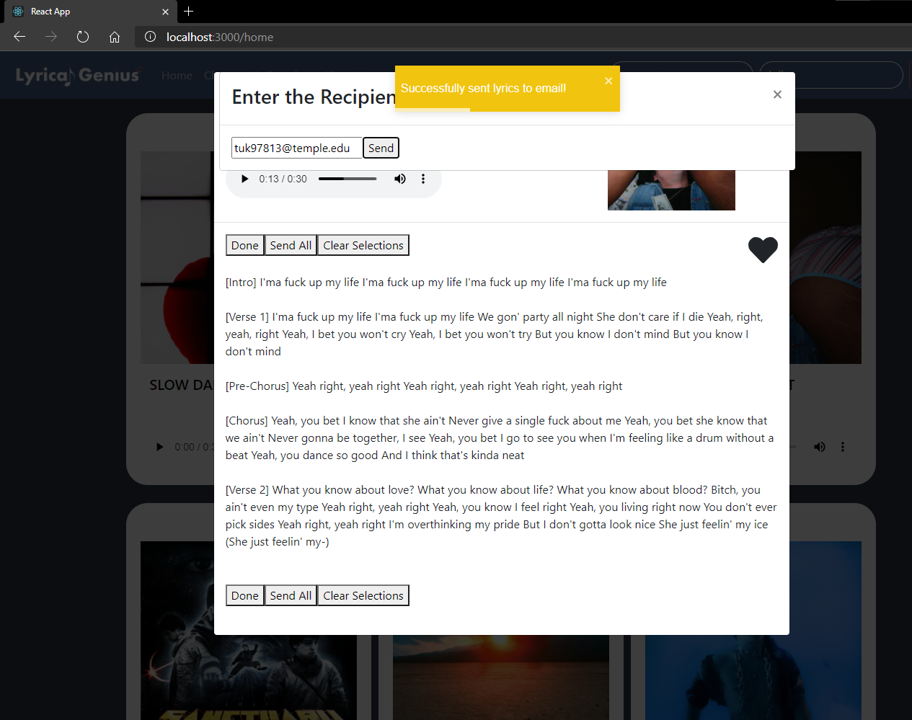

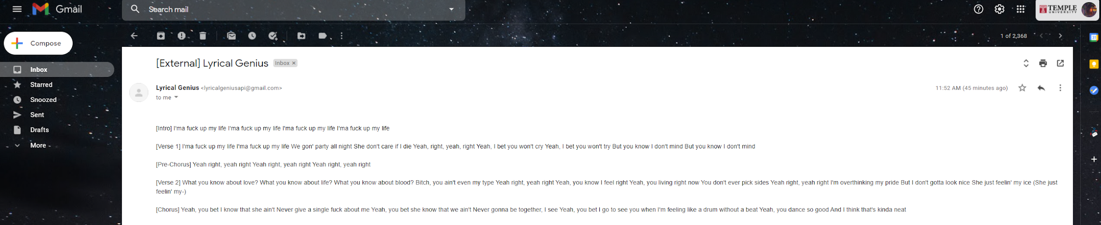

Test Case Phone: